Supplementary Material

**Adhesive *Bifidobacterium* induced changes in cecal microbiome alleviated constipation in mice**

Linlin Wang1,2,3, Cailing Chen1,2, Shumao Cui1,2,3,4, Yuan-kun Lee 5, Gang Wang1,2,3,4*, Jianxin Zhao1,2,4, Hao Zhang1,2,4,6,7, Wei Chen1,2,6,8

* Corresponding author: Gang Wang

E-mail address: [wanggang@jiangnan.edu.cn](mailto:wanggang@jiangnan.edu.cn)

# Supplementary Figures

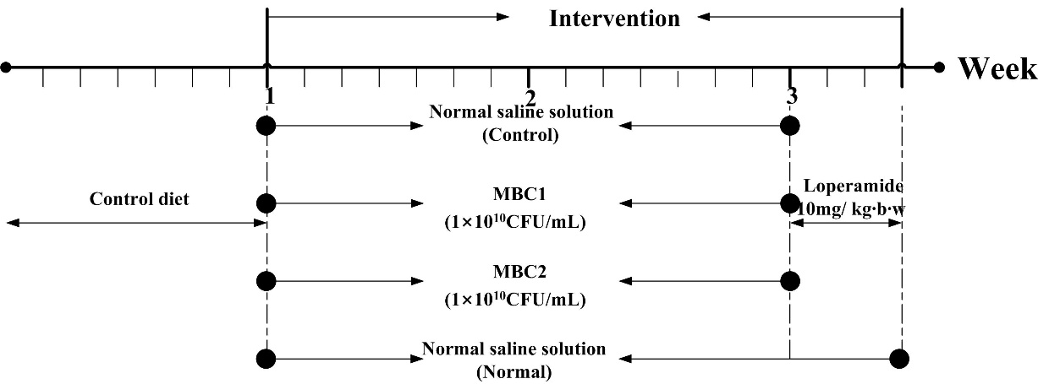

**Supplementary Figure 1.** **Experimental design**

Thirty-two mice were randomly and equally divided into four groups (normal, control, CMB1 and CMB2). In the normal group, mice were gavaged with normal saline solution; in the CMB1 and CMB2 groups, mice were respectively gavaged with 1 × 1010 CFU/mL CMB1 and CMB2 for 2 weeks; from day 15 to day 17, all mice were gavaged with loperamide, except the normal group.

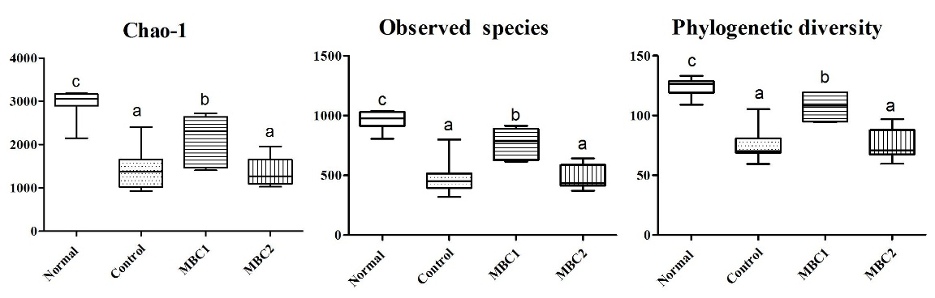

**Supplementary Figure 2.** **Alpha diversity indexes** **of fecal samples in CMB treated mice for 17 days.**

Groups with dissimilar letters differ, *p* < 0.05.

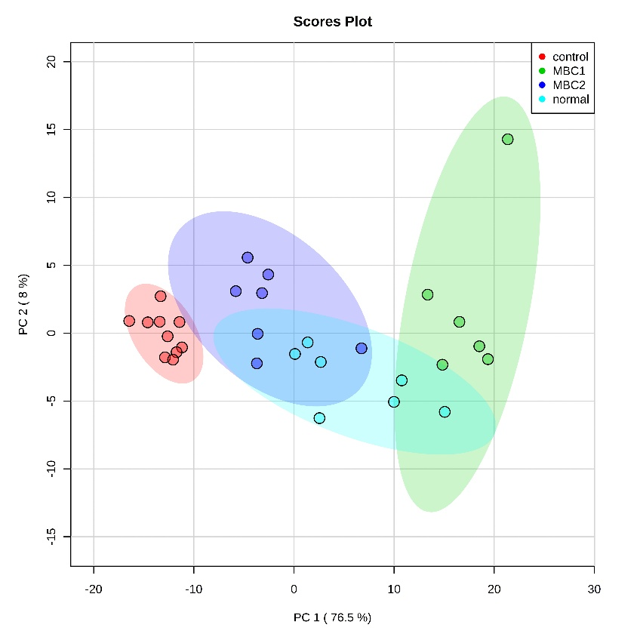

**Supplementary Figure 3. Principal coordinates analysis (PCoA) plots of different treatment groups in faecal groups.**

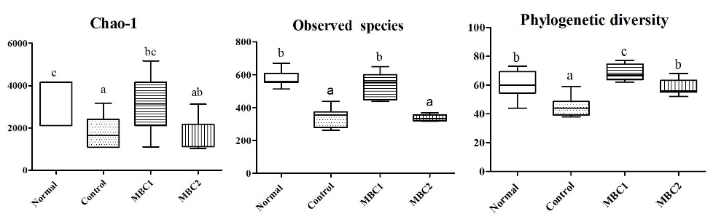

**Supplementary Figure 4. Alpha diversity indexes** **of caecum samples in CMB treated mice for 17 days.**

Groups with dissimilar letters differ, p < 0.05.

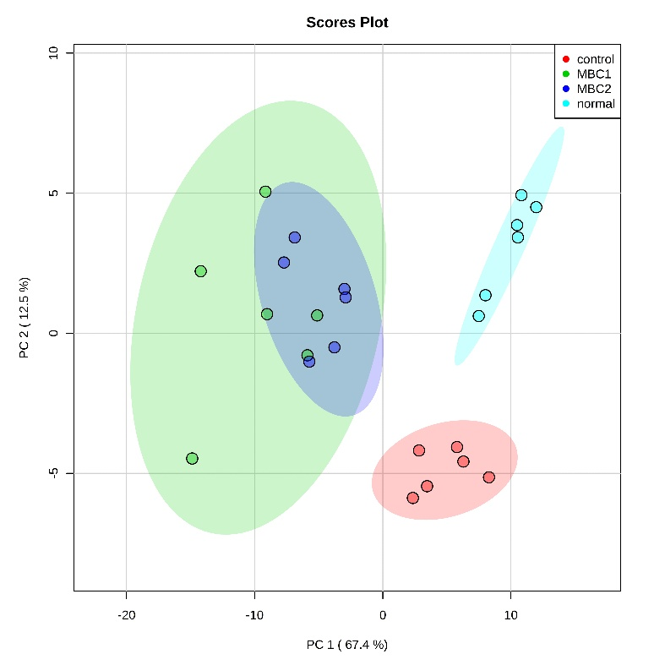

**Supplementary Figure 5. Principal coordinates analysis (PCoA) plots of different treatment groups in caecum samples.**

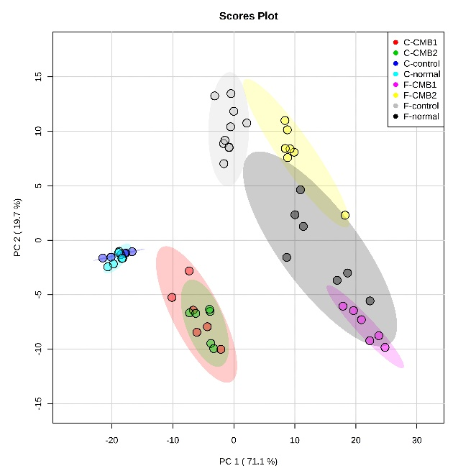

**Supplementary Figure 6. Principal coordinates analysis (PCoA) plots of faecal sample compared to caecum content sample.**

.